Ex. No. : 07 Date :
Register No. : 221701007 Name : AMRITHA A

Telephony Services
Aim
Develop an android application to display the information of the telephony services.

Procedure:
Step 1 : File → New Project
Provide the application name (e.g.,"TelephonyServices") and click “Next”.
Step 2 : Select the target Android devices
Select the minimum SDK to run the application. Click “Next”.
Step 3 : Choose the activity for the application
By default, choose “Blank Activity”. Click “Next”.
Step 4 : Enter activity name and click “Finish”.
Step 5 : Edit the program
Request necessary permissions Request in the manifest file.
Use Kotlin code in MainActivity.kt to implement telephony features ‘
such as dialing a number or retrieving SIM info
Step 6 : Run the application
Two ways to run the application:
1. Running through emulator (with SD card configured)
2. Running through mobile device

AndroidManifest.xml

<?xml version="1.0" encoding="utf-8"?>
<manifest xmlns:android="http://schemas.android.com/apk/res/android"
package="com.example.telephony services">

<!-- Telephony permissions -->
<uses-permission android:name="android.permission.READ_PHONE_STATE" />
<uses-permission android:name="android.permission.READ_PHONE_NUMBERS" />

<!-- Feature requirements -->
<uses-feature android:name="android.hardware.telephony" android:required="false" />

<application
android:allowBackup="true"
android:icon="@mipmap/ic_launcher"
android:label="@string/app_name"
android:roundIcon="@mipmap/ic_launcher_round"
android:supportsRtl="true"
android:theme="@style/Theme.TelephonyServices">
<activity
android:name=".MainActivity"
android:exported="true">
<intent-filter>
<action android:name="android.intent.action.MAIN" />
<category android:name="android.intent.category.LAUNCHER" />
</intent-filter>
</activity>
</application>

</manifest>

Activity_main.xml

<?xml version="1.0" encoding="utf-8"?>
<LinearLayout xmlns:android="http://schemas.android.com/apk/res/android"
xmlns:app="http://schemas.android.com/apk/res-auto"
xmlns:tools="http://schemas.android.com/tools"
android:layout_width="match_parent"
android:layout_height="match_parent"
android:orientation="vertical"
tools:context=".MainActivity">

<TextView
android:layout_width="match_parent"
android:layout_height="wrap_content"
android:text="Telephony Services"
android:textSize="22sp"
android:textStyle="bold"
android:textColor="@android:color/white"
android:padding="16dp"
android:background="#6200EE" />

<!-- Network Operator Name -->
<TextView
android:layout_width="match_parent"
android:layout_height="wrap_content"
android:text="Network Operator Name"
android:textSize="14sp"
android:paddingStart="16dp"
android:paddingTop="8dp"
android:textColor="#757575"/>

<TextView
android:id="@+id/networkOperatorNameTextView"
android:layout_width="match_parent"
android:layout_height="wrap_content"
android:background="@drawable/text_view_border"
android:padding="16dp"
android:textSize="16sp"
android:textColor="#212121"
tools:text="Android" />

<!-- Phone Type -->
<TextView
android:layout_width="match_parent"
android:layout_height="wrap_content"
android:text="Phone Type"
android:textSize="14sp"
android:paddingStart="16dp"
android:paddingTop="8dp"
android:textColor="#757575"/>

<TextView
android:id="@+id/phoneTypeTextView"
android:layout_width="match_parent"
android:layout_height="wrap_content"
android:background="@drawable/text_view_border"
android:padding="16dp"
android:textSize="16sp"
android:textColor="#212121"
tools:text="GSM" />

<!-- Network Country ISO -->
<TextView
android:layout_width="match_parent"
android:layout_height="wrap_content"
android:text="Network Country ISO"
android:textSize="14sp"
android:paddingStart="16dp"
android:paddingTop="8dp"
android:textColor="#757575"/>

<TextView
android:id="@+id/networkCountryIsoTextView"
android:layout_width="match_parent"
android:layout_height="wrap_content"
android:background="@drawable/text_view_border"
android:padding="16dp"
android:textSize="16sp"
android:textColor="#212121"
tools:text="US" />

<!-- SIM Country ISO -->
<TextView
android:layout_width="match_parent"
android:layout_height="wrap_content"
android:text="SIM Country ISO"
android:textSize="14sp"
android:paddingStart="16dp"
android:paddingTop="8dp"
android:textColor="#757575"/>

<TextView
android:id="@+id/simCountryIsoTextView"
android:layout_width="match_parent"
android:layout_height="wrap_content"
android:background="@drawable/text_view_border"
android:padding="16dp"
android:textSize="16sp"
android:textColor="#212121"
tools:text="US" />

<!-- Device Software Version -->
<TextView
android:layout_width="match_parent"
android:layout_height="wrap_content"
android:text="Device Software Version"
android:textSize="14sp"
android:paddingStart="16dp"
android:paddingTop="8dp"
android:textColor="#757575"/>

<TextView
android:id="@+id/deviceSoftwareVersionTextView"
android:layout_width="match_parent"
android:layout_height="wrap_content"
android:background="@drawable/text_view_border"
android:padding="16dp"
android:textSize="16sp"
android:textColor="#212121"
tools:text="---" />

<View
android:layout_width="match_parent"
android:layout_height="0dp"
android:layout_weight="1" />

<Button
android:id="@+id/getServicesButton"
android:layout_width="match_parent"
android:layout_height="wrap_content"
android:text="Get Telephony Services"
android:textColor="@android:color/white"
android:backgroundTint="#6200EE"
android:padding="16dp"
android:layout_margin="16dp"/>

</LinearLayout>

MainActivity.kt

package com.example.telephony services
import android.Manifest
import android.content.Context
import android.content.pm.PackageManager
import android.os.Bundle
import android.telephony.TelephonyManager
import android.widget.Button
import android.widget.TextView
import android.widget.Toast
import androidx.appcompat.app.AlertDialog
import android.appcompat.app.AppCompatActivity
import android.core.app.ActivityCompat
import androidx.core.content.ContextCompat

class MainActivity : AppCompatActivity() {
private lateinit var networkOperatorNameTextView: TextView
private lateinit var phoneTypeTextView: TextView
private lateinit var networkCountryIsoTextView: TextView
private lateinit var simCountryIsoTextView: TextView
private lateinit var deviceSoftwareVersionTextView: TextView
private lateinit var getServicesButton: Button

private val TELEPHONY_PERMISSION_CODE = 101

override fun onCreate(savedInstanceState: Bundle?) {
super.onCreate(savedInstanceState)
setContentView(R.layout.activity_main)

// Initialize UI components
networkOperatorNameTextView = findViewById(R.id.networkOperatorNameTextView)
phoneTypeTextView = findViewById(R.id.phoneTypeTextView)
networkCountryIsoTextView = findViewById(R.id.networkCountryIsoTextView)
simCountryIsoTextView = findViewById(R.id.simCountryIsoTextView)
deviceSoftwareVersionTextView = findViewById(R.id.deviceSoftwareVersionTextView)
getServicesButton = findViewById(R.id.getServicesButton)

// Set click listener for button
getServicesButton.setOnClickListener {
checkTelephonyPermission()
}
}

private fun checkTelephonyPermission() {
if (ContextCompat.checkSelfPermission(
this,
Manifest.permission.READ_PHONE_STATE
) != PackageManager.PERMISSION_GRANTED
) {
// Show permission explanation dialog
showPermissionDialog()
} else {
// Permission already granted, get telephony info
getTelephonyInfo()
}
}

private fun showPermissionDialog() {
AlertDialog.Builder(this)
.setTitle("Allow Telephony Services")
.setMessage("to make and manage phone calls?")
.setIcon(R.drawable.ic_phone)
.setPositiveButton("ALLOW") { _, _ ->
// Request permission
ActivityCompat.requestPermissions(
this,
arrayOf(Manifest.permission.READ_PHONE_STATE),
TELEPHONY_PERMISSION_CODE
)
}
.setNegativeButton("DENY") { dialog, _ ->
dialog.dismiss()
Toast.makeText(
this,
"Permission denied. Cannot access telephony services.",
Toast.LENGTH_SHORT
).show()
}
.create()
.show()
}

private fun getTelephonyInfo() {
val telephonyManager = getSystemService(Context.TELEPHONY_SERVICE) as TelephonyManager

// Get network operator name
val networkOperatorName = if (ActivityCompat.checkSelfPermission(
this,
Manifest.permission.READ_PHONE_STATE
) == PackageManager.PERMISSION_GRANTED
) {
telephonyManager.networkOperatorName.ifEmpty { "Android" }
} else {
"Permission required"
}
networkOperatorNameTextView.text = networkOperatorName

// Get phone type
val phoneType = when (telephonyManager.phoneType) {
TelephonyManager.PHONE_TYPE_GSM -> "GSM"
TelephonyManager.PHONE_TYPE_CDMA -> "CDMA"
TelephonyManager.PHONE_TYPE_SIP -> "SIP"
TelephonyManager.PHONE_TYPE_NONE -> "NONE"
else -> "UNKNOWN"
}
phoneTypeTextView.text = phoneType

// Get network country ISO
val networkCountryIso = telephonyManager.networkCountryIso.uppercase().ifEmpty { "US" }
networkCountryIsoTextView.text = networkCountryIso

// Get SIM country ISO
val simCountryIso = telephonyManager.simCountryIso.uppercase().ifEmpty { "US" }
simCountryIsoTextView.text = simCountryIso

// Get device software version
val deviceSoftwareVersion = if (ActivityCompat.checkSelfPermission(
this,
Manifest.permission.READ_PHONE_STATE
) == PackageManager.PERMISSION_GRANTED
) {
telephonyManager.deviceSoftwareVersion ?: "---"
} else {
"---"
}
deviceSoftwareVersionTextView.text = deviceSoftwareVersion

Toast.makeText(this, "Telephony information updated", Toast.LENGTH_SHORT).show()
}

override fun onRequestPermissionsResult(
requestCode: Int,
permissions: Array<String>,
grantResults: IntArray
) {
super.onRequestPermissionsResult(requestCode, permissions, grantResults)
if (requestCode == TELEPHONY_PERMISSION_CODE) {
if (grantResults.isNotEmpty() && grantResults[0] == PackageManager.PERMISSION_GRANTED) {
// Permission granted, get telephony info
getTelephonyInfo()
} else {
Toast.makeText(
this,
"Permission denied. Cannot access telephony services.",
Toast.LENGTH_SHORT
).show()
}
}
}
}
Output

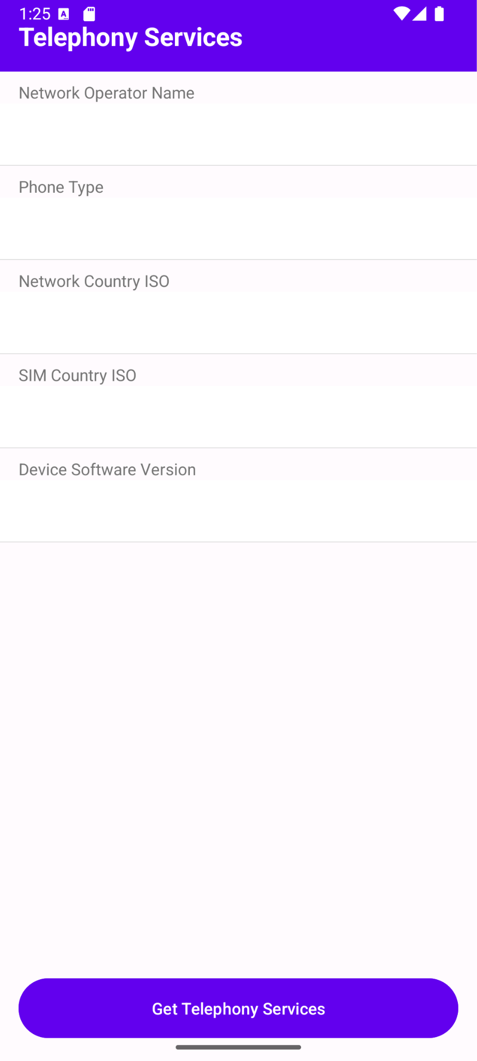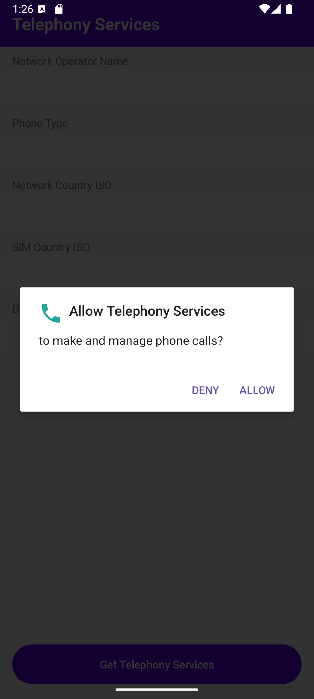
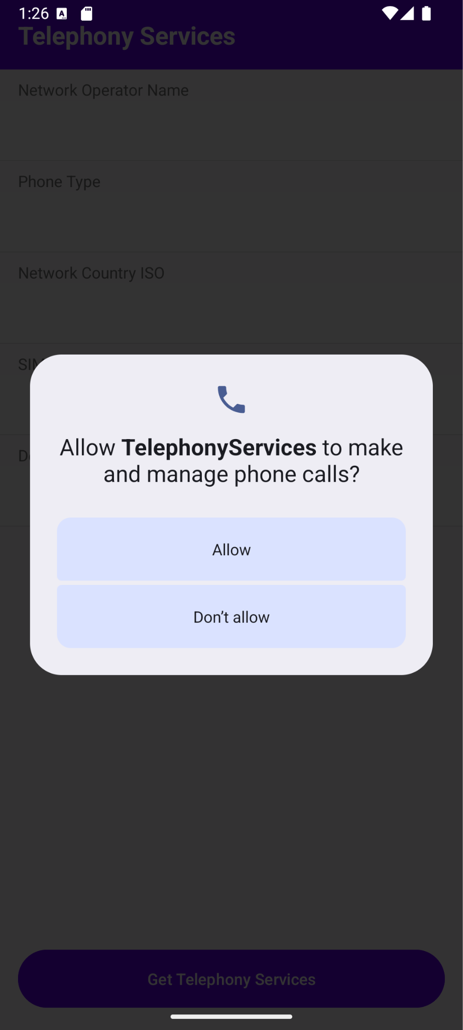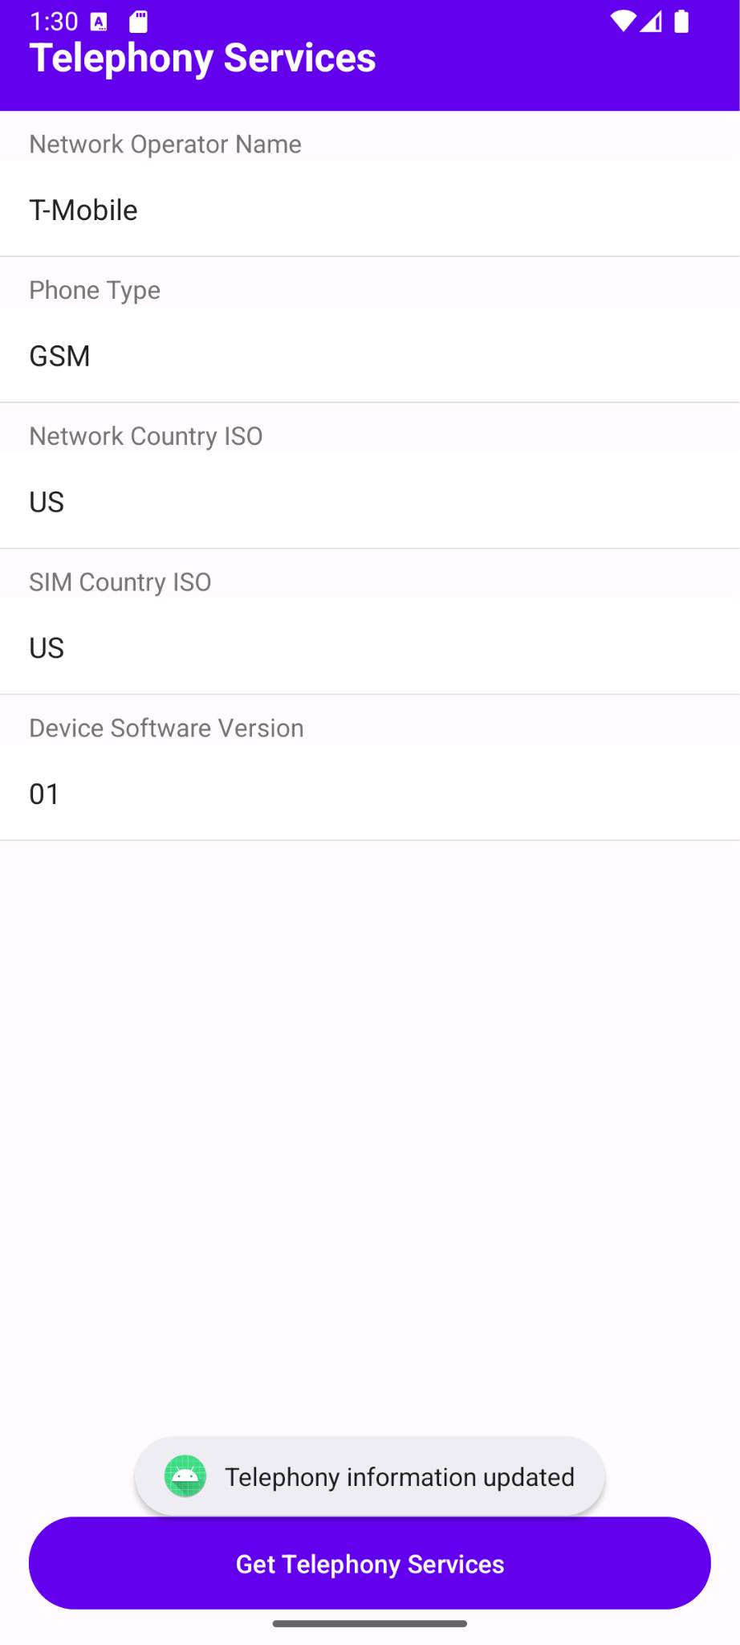

Result:
The Telephony Services application successfully accesses telephony features like initiating phone calls or displaying SIM and network information on a mobile device with granted permissions.

